* -: Welcome to a new core section.
* This core section is about Pipes, and let's start with the most important question first,
* **what are Pipes?**
* Pipes are a feature built into Angler two, which basically allows you to ***transform output in your template.***
* This is the main purpose of a pipe.
* It transforms some output.
* Now, there are pipes for different types of output, and also for synchronous and asynchronous data.
* We will have a look at this throughout the course.
* The general theme is always the same, though.
* A basic example would be the following.
* You have a username, that's a property in your component.
* For example, here, it holds a string, Max.
* Now you want your output, that username in your template.
* And for this, you probably use string interpolation, as you learn it throughout the course.
* Now, that's all right, but then you decide it would be nice if the output, which is Max, if you do it like this.
* would be all upper case, but only when you output it.
* So, you don't wanna change the property itself to uppercase, because imagine you use that for all your code, and it should still be well, as you assigned it up there, but you want to transform the way it is displayed once you render it to the screen.
* Now, for this, you could use a pipe.
* Namely the uppercase pipe.

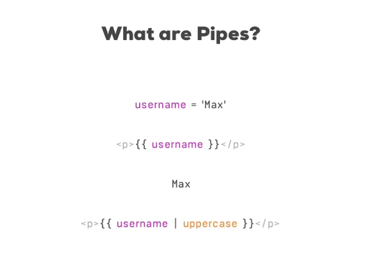

* This actually would be a built-in pipe, and we will have a look at the built-in pipes in a second.
* Now, with that built-in pipe in use, you would now see Max, all uppercase being printed to the screen because this is what this pipe does.
* It transforms the value.
* Now, that is the main purpose of pipes, transforming values.
* Let's dive into them a bit more.
* Let's view some of the built-in pipes and then let's also build our own pipes.
* Let's go.